14/06/20
THM 415: Finance
Final Exam Answer Sheet
Note to the students:
- Calculations to reach your answers shall be thoroughly shown. Otherwise, questions will NOT be graded.
- You can use a calculator throughout the exam.
1. Your grandfather is retired and living on his Social Security benefits and the interest he gets from savings. However, the interest incomes he receives decreased recently to only 2 % a year on his $ 200,000 in savings. You have been thinking about recommending that he purchase some corporate bonds with at least part of his savings as a way of increasing his interest income.
Specifically, you have identified three corporate bond issues for your grandfather to consider. The following table summarizes these very corporate bonds:
Moreover, the following depicts corporate bonds spread table (in basis points):
Before recommending any of these bond issues to your grandfather, you wanted to perform a number of analyses. Specifically, you want to address each of the following issues:
- Estimate an appropriate market’s required yield to maturity for each of the bond issues. (1.50 Points)
- Required Yield to Maturity (Jamel Corporation) = 2.96 % + 2.01 % = 4.97 %.
- Required Yield to Maturity (BJK Inc.) = 3.48 % + 4.51 % = 7.99 %.
- Required Yield to maturity (Karakartal Inc.) = 2.14 % + 0.81 % = 2.95 %.
- What is the yield to maturity for each bond? (1.50 Points)
- Yield to Maturity (Jamel Corporation) = Rate (10*2, 1000*7.80%/2, -1028, 1000) * 2 = 7.40 %.
- Yield to Maturity (BJK Inc.) = Rate (17*4, 1000*7.50%/4, -903, 1000) * 4 = 8.59 %.
- Yield to Maturity (Karakartal Inc.) = Rate (4*6, 1000*7.98%/6, -903, 1042) * 6 = 6.78 %.
- Given your estimate of the proper discount rate, what is your estimate of the value of each of the bonds? In light of the current market price of each bond, which issue do you think is most attractively priced? (2 Points)
- Value (Jamel Corporation) = - PV (4.97%/2, 10*2, 1000*7.80%/2, 1000) = $ 1,220.90.
- Value (BJK Inc.) = - PV (7.99%/4, 17*4, 1000*7.50%/4, 1000) = $ 954.65.
- Value (Karakartal Inc.) = - PV (2.95%/6, 4*6, 1000*7.98%/6, 1000) = $ 1,189.34.
Even though the 3 bond issues seem to be underpriced (certainly this is a good thing for investors), it seems that Jamel Corporation issue is the most attractive as it yields the highest amount of savings when comparing the should-be-market price (i.e. $ 1,220.90) with the actual market price (i.e. $ 1,028) leaving an investor of such an issue with a savings of $ 192.90. This very saving is the highest when compared with the other 2 bond issues.
- How would the values of the bonds change if (i) the market required yield to maturity on a comparable-risk bond increases by 10 % above the proper discount rate or (ii) decreases by 10 % under the proper discount rate? Which of the bond issues is the most sensitive to changes in the rate of interest? (2 Points)
(i) Market Required Yield to Maturity increases by 10 %:
- Value (Jamel Corporation) = - PV (5.47%/2, 10*2, 1000*7.80%/2, 1000) = $ 1,177.90.
- Value (BJK Inc.) = - PV (8.79%/4, 17*4, 1000*7.50%/4, 1000) = $ 886.79.
- Value (Karakartal Inc.) = - PV (3.25%/6, 4*6, 1000*7.98%/6, 1000) = $ 1,177.17.
(i) Market Required Yield to Maturity decreases by 10 %:
- Value (Jamel Corporation) = - PV (4.47%/2, 10*2, 1000*7.80%/2, 1000) = $ 1,265.90.
- Value (BJK Inc.) = - PV (7.19%/4, 17*4, 1000*7.50%/4, 1000) = $ 1,030.18.
- Value (Karakartal Inc.) = - PV (2.66%/6, 4*6, 1000*7.98%/6, 1000) = $ 1,201.66.
Now let’s look at the following comparative tables for each of the 3 bond issues:
As can be seen from the above tables, it is obvious as BJK Inc. bond issue is the most sensitive to changes in the rate of interest as a 10 % increase as well as 10 % decrease of the required yield to maturity on that very bond issue engenders the highest fluctuation in price (i.e. 7.91 % increase and 7.11 % decrease respectively). This price sensitivity is the highest when compared with the other 2 bond issues.
2. Talisca Corporation is considering three mutual exclusive investments. The projects’ expected net cash flows are as follows:
a) What is the Net Present Value of Projects A, B and C at an appropriate discount rate of 4.04%? (1.50 Point)
- NPV (Project A) = NPV (4.04%, 14289, 18743, -1903, -1547, 8456, 15428, 20369, -1954, 8763, 13528, -370, -415, 5001, -875, 7896) – 75563 = $ 7,179.30.
- NPV (Project B) = NPV (4.04%, 5873, 7450, 3062, -1245, -1026, 5742, 7542, 9563, -4042, 9574) – 30003 = $ 4,161.82.
- NPV (Project C) = NPV (4.04%, -1248, 6089, -1045, 10589, -314, 7529) – 15423 = $ 2,791.41.
b) What is the Equivalent Annual Cost of Projects A, B and C? (1.50 Point)
- EAC (Project A) = PMT (4.04%, 15, -7179.30, 0) = $ 647.52.
- EAC (Project B) = PMT (4.04%, 10, -4161.82, 0) = $ 514.14.
- EAC (Project C) = PMT (4.04%, 6, -2791.41, 0) = $ 533.19.
c) What are the Payback Periods for Project A, B and C? (1.50 Points)
- Payback Period (Project A) = 8.42 Years.
- Payback Period (Project B) = 7.27 Years.
- Payback Period (Project C) = 5.18 Years.
d) What are the MIRR’s for Project A, B and C? (3 Points)
- MIRR (Project A) = IRR (-80996.46, 14289, 18743, 0, 0, 8456, 15428, 20369, 0, 8763, 13528, 0, 0, 5001, 0, 7896) = 5.60 %.
- MIRR (Project B) = IRR (-34737.32, 5873, 7450, 3062, 0, 0, 5742, 7542, 9563, 0, 9574) = 6.24 %.
- MIRR (Project C) = IRR (-15423, 0, 6089, 0, 10589, 0, 7529) = 7.91 %.
e) Based on MIRR, which project shall be chosen? Why? (1 Point)
Based only on MIRR (there are problems with rankings of the projects if we don’t use NPV though), project C shall be chosen because its MIRR (7.91 %) is at the same time greater than discount rate (4.04 %) and the highest amongst other projects (all modified projects are conventional cash flow patterns).
3. Barbaros Company is considering an independent project. The project’s expected net cash flows are as follows:
a) Calculate project’s IRR. (1 Point)
- IRR (Project) = IRR (-1030, 1000, 1100, 1200, 1300, -3850) = 4.79 %.
b) Draw the NPV profile for the project starting with a discount rate of 0% and increments of 5 % until you reach a discount rate of 90 %. (3 Points)
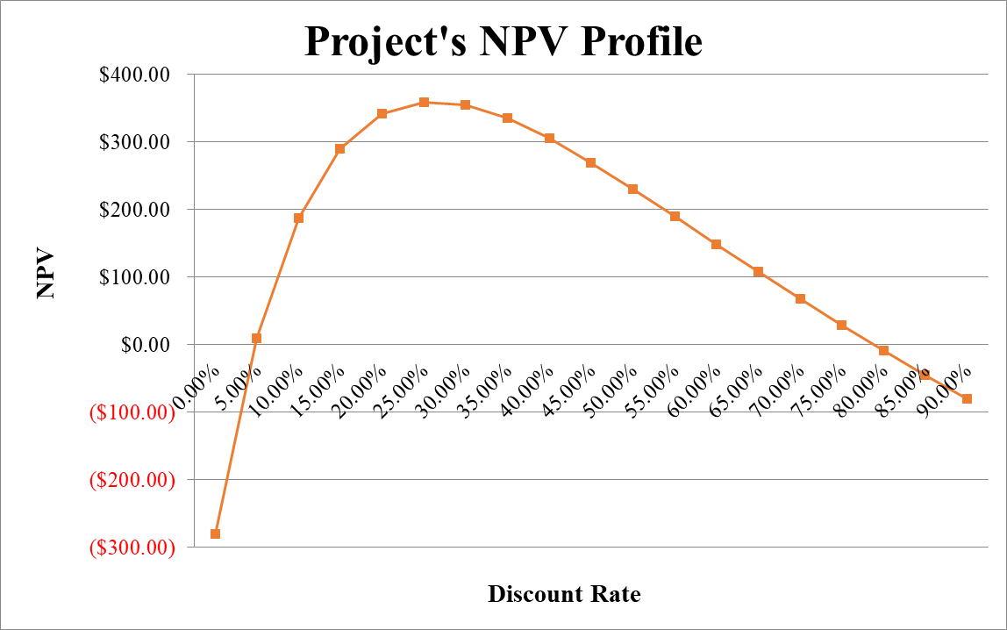
c) Referring to the NPV Profile prepared in part b), what is the second IRR of the project? (2 Points)
The second IRR of the project occurs when the discount rate used is 78.77 %.
d) What is your decision as far as to accept the project or reject it? (2 Points)
If the appropriate discount rate used to evaluate this very project is between 4.79 % and 78.77 %, accept the project. Otherwise, reject it.
4. Slamp Corporation, a firm in the 45 % marginal tax bracket with a 9.03 % required rate of return or discount rate, is considering a new project. This project involves the introduction of a new product. This project is expected to last 7 years and then, because this is somewhat of a fad product, it will be terminated. Moreover, the following bits of information are pertinent to this very new project:
- Cost of new plant and equipment: $ 7,250,000
- Shipping and installation costs: $ 625,000
Year | Units Sold
1 | 120,000
2 | 140,000
3 | 160,000
4 | 180,000
5 | 145,000
6 | 85,000
7 | 20,000
- Sales price per unit: $ 75 in year 1; expected to increase by 5 % on a yearly basis.
- Variable cost per unit: $ 40 in year1; expected to increase by 3 % on a yearly basis.
- Annual fixed costs: $ 2,850,000
- Working capital requirements: There will be an initial working capital requirement of $ 750,000 just to get production started. For each year, the total investment in net working capital will equal 8 % of the dollar value of sales for that year. In the final year, all working capital is liquidated at the termination of the project.
- The depreciation method: Use the simple straight line method over 7 years. It is assumed that the plant and equipment will have $ 350,000 salvage value after 7 years.
a) Determine the yearly net free cash flows associated with the project? (5 Points)
b) Sketch a timeline for this new project? (0.50 Points)
c) Calculate the Profitability Index of the project? (1 Point)
- Profitability Index = NPV (9.03%, 1256250, 1645600, 2281982, 2992582, 2788868, 1629957, 497349) / (8625000) = 1.10 times.
d) Shall the project be undertaken? Why? Why not? (1 Point)
Since profitability index of the estimated cash flows of the project is greater than 1, Slamp Corporation shall undertake the project.
5. Carew Company is evaluating the purchase of John Company. As a first step, Carew Company wants to determine the Weighted Average Cost of Capital (WACC) (i.e. the appropriate discount rate to discount future estimated cash flows of Caner Company). In this regard, Carew Company determined the following dollar values pertinent to the right hand-side of the balance sheet of John Company:
- What is the weight attributed to each source of capital? (1 Point)
First of all, not all liability and owners’ equity accounts are source of capital. We have to discard accounts payable and accrued expenses. Moreover, we have to look at market values instead of book values. In this regard, the weight attributed to each source of capital is depicted in the following table:
While short debt is entirely coming from a loan obtained from a private bank with a yearly interest rate of 9.03 %, long term debt is entirely coming from a 17-year issued bond (with 12 years to maturity) 8.23 % coupon rate and interest paid on a monthly basis. The bond price is currently traded at $ 915.33. Lastly suppose that marginal tax rate is 42.16 %.
- What is the cost of short-term debt? (1 Point)
- Cost of short-term debt = 9.03 % *(1 – 42.16 %) = 5.22 %.
- What is the cost of long-term debt? (1 Point)
- Yield to maturity = Rate (12*12, (1000*8.23%)/12, - 915.33, 1000) * 12 = 0.78 % * 12 = 9.41 %.
- Cost of long-term debt = 9.41 % * (1 – 42.16 %) = 5.44 %.
- If preferred stocks issued by John Company pays 7.24 % annual dividend and those very preferred stocks are traded currently at $ 1,205.33, what is the cost of preferred stock? (1 Point)
- Preferred stock dividend = 1,000 * 7.24 % = $ 72.40.
- Cost of preferred stock = (72.40 / 1,205.33) * 100 = 6.01 %.
Suppose that John common stockholders have received dividends (pertaining to last year) of $ 6.14 per share and that very company’s common stocks are traded currently at $ 535.67 per share. Lastly, John Company has paid the following dividends during the last 9 years:
- What is the cost of common stock? (1 Point)
Since geometric average takes into account the effect of compounding, it is a better measurement of the common stock growth rate.
- Growth Rate = 5.40 %
- Dividend 1 = 6.14 * (1 + 5.40 %) = $ 6.47
- Cost of common stock = (6.47 / 535.67) + 5.40 % = 6.61 %.
- What is the Weighted Average Cost of Capital (WACC) of John Company? (1 Point)
- Suppose Carew Company is in need of $ 82,000,000 to finalize the acquisition of John Company. Moreover, the amount needed will be financed 43 % through issuance of common stock and the remaining through issuance of bonds. Lastly, the intermediary bank responsible for the financing told that issue costs associated with bonds is 6.14 % while issue costs associated with equity is 8.93 %. What is the floatation cost associated with the acquisition of John Company? (1 Point)
- Floatation cost of issuance of bonds = 6.14 %
- Weight of bonds in financing = 57 %
- Cost of issuance of common stock = 8.93 %
- Weight of common stocks in financing = 43 %
- Weighted average floatation cost = (57 % * 6.14 %) + (43 % * 8.93 %) = 7.34 %.
- Floatation cost associated with acquisition = 82,000,000 / (1 – 7.34 %) = $ 88,495,288.71.
Carew Company uses Discounted Payback Period as the criterion to decide whether to finalize the purchase or not. Moreover, Carew Company values 6 years as the cutoff period. Finally, the estimated cash flow generated from the purchase of John Company for the next 10 years is depicted as the following:
- Shall the acquisition be finalized? Why? Why not? (Show all necessary calculations) (2 Points)
The estimated cash flow generated from John Company is as follows:
Since Carew Company uses discounted payback period to evaluate its projects, we shall calculate the discounted payback period of John Company (bearing in mind that discount rate is 5.81 %):
- Discounted Payback Period (John Company) = 6.94 Years.
→ Since discounted payback period (i.e. 6.94 Years) is greater than cutoff period (i.e. 6 years), Carew Company shall NOT finalize the acquisition of John Company.
Good Luck

